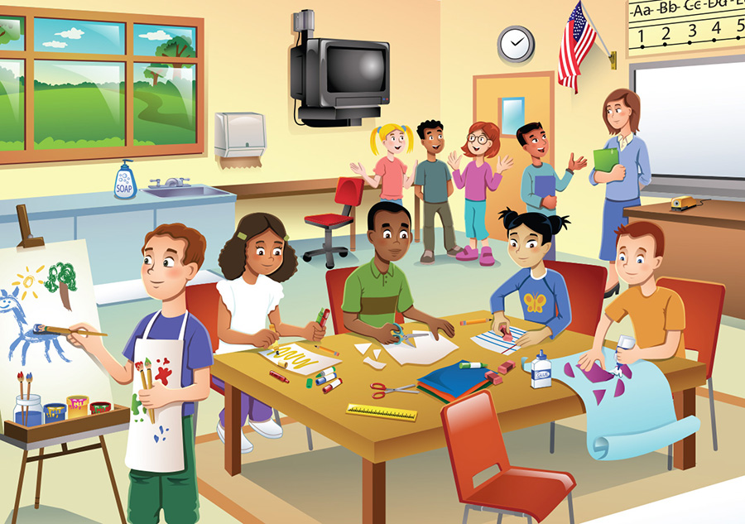

1. Write about this picture (Where? Who? What are they doing? – left, right, background, foreground etc.)

_____________________________________________________________________________________________

_____________________________________________________________________________________________

_____________________________________________________________________________________________

_____________________________________________________________________________________________

_____________________________________________________________________________________________

_____________________________________________________________________________________________

_____________________________________________________________________________________________

_____________________________________________________________________________________________

_____________________________________________________________________________________________

_____________________________________________________________________________________________

_____________________________________________________________________________________________

1. **Complete**

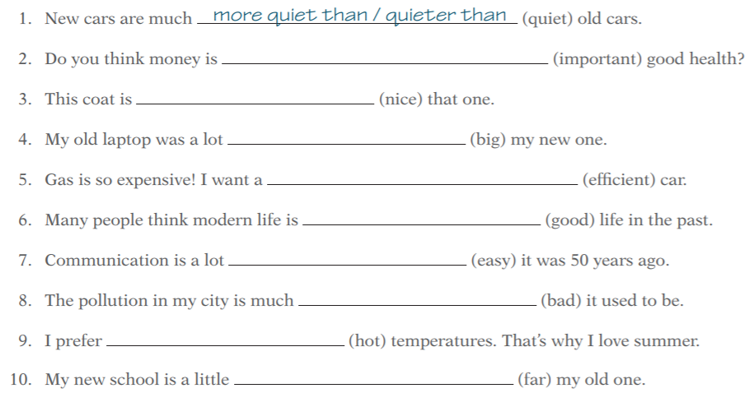

**3. Read the text and decide if the statements are true or false.**

